**SUB QUERY:**

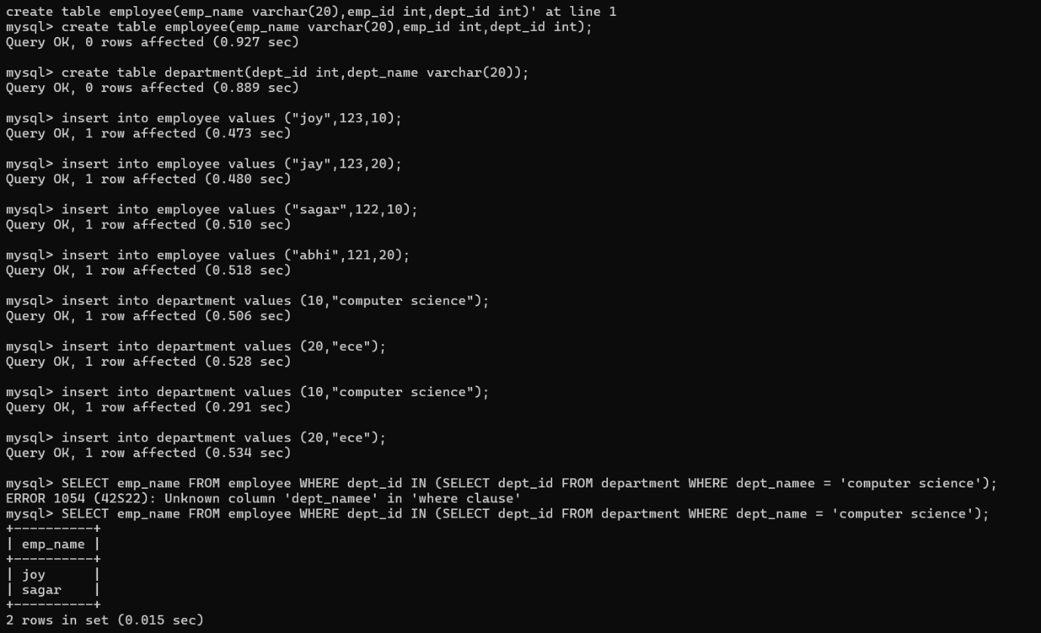

**CORRELATED SUBQUERY:**

